**Date:** 10/1/2024

Today I worked on getting the AGV to move. The team started ruling out some of the reasons as to why the AGV failed to move when power was applied to it. Previous teams working on the project did not include any documentation on their progress towards getting it to move, so I had to do some additional research on the components that were preinstalled onto the AGV. After applying the necessary power requirements, the team took to seeing if some of the other components found near the chassis would remedy the issue and allow us to interface with the AGV. Unfortunately, our attempt was futile, however, one of our teammates was messing with the motor controller and was able to make an adjustment to the switch onboard and the motors began to move. After reviewing some additional documentation about the motor controller and the way they interact with the motors, I concluded that depending on the combination in which the switches are aligned, it will determine how the controller will interface with different devices to receive input, as well as how it relays the input to the motors.

Some additional things worth looking into are listed below:

* How to interface with a device that is programmable
* Since it only seems to be feeding back input from the power supply, what combination would alter the output to the motors
* 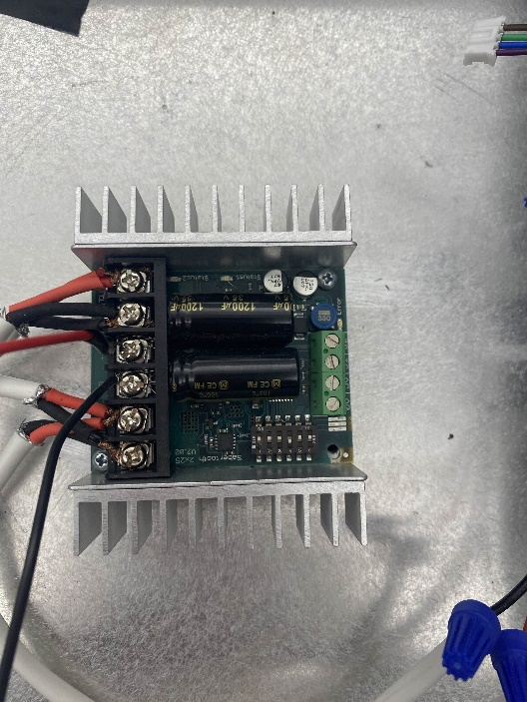How to modify the chassis to fit additional components and a 24V battery

*Picture of Controller Switch*

**Date:** 10/3/2024

Not much was done today unfortunately. Most of the time was put towards discussing the changes to the scope of the project by the professor, as well as a customer that has taken an interest in the AGV.

The original scope of the project was to create an autonomous vehicle tasked with locating bodies amid a disaster. It would include different sensors to alert responders and determine the state of the bodies found so that it may relay that information to responders as well.

The new proposed project involved using an autonomous vehicle with an inverted radar to locate and identify UAVs and relay the information to a centralized location. This project would be more applicable to the interests of the customer.

As a team, we had to decide which direction was more appropriate for the allotted time and resources. However, logistical issues arose concerning the feasibility of installing a radar due to legal constraints. So, now, progress is stagnated until there is more clarity on a direction forward.

*Picture of Board*

**Date:** 10/7/2024

Today I met with a few members of the team to get clarification on the direction of the project. The consensus seems to be that we are proceeding with the scope of the original project with some modifications. However, there are still more details to discuss before delving deeper into the project.

I also met with a couple members of the team in the Senior Design Lab and after discussing the scope of the project, we began working on establishing a serial connection to the AGV so that we may program test movements. Prior to interfacing with the motor controller, I adjusted the switch settings so that it enables us to use an Arduino to interface with the AGV. After connecting the Arduino to the motor controller and uploading test code to it, we saw signs that it was receiving the input and was communicating it with the motors onboard. We conducted a few more tests and concluded that we have a solid connection to the AGV, but it will require further testing so that it may run without error.

Some next steps are listed below:

* Continue to workshop the interfacing code
* Look into how it will communicate with a central device/location and what devices will be involved to make it happen
* A machine with wires and wires

  Description automatically generatedFurther develop autonomous capabilities

*Picture of AGV*

**Date:** 10/9/2024

Documentation for previous work has been updated and journaled. Scrumwise has also been updated to reflect the updates to the work done for the sprint.

Given the dire weather conditions, the team is unfortunately unable to meet any further this week and is not able to work on the AGV until further notice.

**Date:** 10/15/2024

Today I met with the team business as usual. Collectively we managed to decide how to move forward with our project given the initial uncertainty of direction; and we decided that we are going with the original project idea.

I also assisted the Software Team with troubleshooting the movement of the AGV, as an extension of the work done on it the previous week. It was having issues where one pair of motors was moving at one speed while the other was moving significantly slower. I did some analysis of the hardware as the software written was verified to not present any noticeable conflicts. I tested to see if there was a lack of power being received by the slower motors and there in fact was one. However, I was not sure if it was an issue with the wires or if it was an issue with the motor controller, so I decided to swap the connections to the motors on the controller to verify. After running a test with the swapped connections, the motors with the initially slower movement were now moving at full speed while the other previously normal working motors were now moving slower. This test concluded that there was in fact an issue with the motor controller, so to remedy this we are going to order another part, and quite possibly a few more just in case, so that we hopefully do not have to deal with any future issues that may occur if we had decided to try and repair it.

The new sprint (Sprint 3) also started today so once we got everything, we needed into the Scrumwise, we started it and began working.

**Date:** 10/16/2024

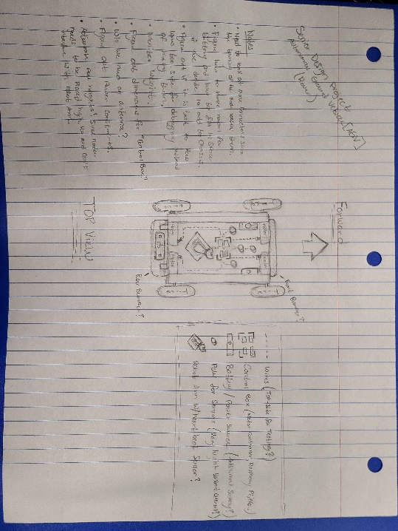I worked on drafting a preliminary mock-up of how we foresee the AGV from a hardware perspective given all the requirements and systems the team wants to utilize. I included a top-view sketch of the AGV; I included a key identifying each of the components atop the AGV; I included some comments on possible approaches to tackling each component; and I also included some notes on things that we need to consider and some potential issues that may arise.

*Picture of Mock-Up*

I also looked at one of the suggested components, a radar, that the Communication Team had picked out to verify any power issues that could occur. After reading over the manual for the radar, I verified that the power requirements should be within our capabilities to work with, however, one issue I did find was the height at which we had to place it. To be effective, the radar would need to be placed approximately 3-meters high, unless placed at an angle which would require looking more into and have no interference with any of the other components on the AGV. I potentially came up with a solution, but it will require further expanding upon given some of the other constraints.

More information about possible solutions and other notes on the mock-up are listed below:

* Need to at axle connectors/bearings since the turning of the axle loosens them
* Figure out how to make room for the battery and how to fill in empty space if we decide to add to chassis
* Decide whether it is better to keep wires visible and accessible for debugging instead of hiding them
* Monitor weight
* Figure out dimensions for “Control Box”
* Figure out if we need an antenna to transmit or receive
* Figure out power constraints, if any
* Adjustable pole height? Since radar needs to be placed high up and cannot interfere with robot arm (solution mentioned above)